DDoS protection - AWS Shield Advanced
Service Overview
Service Description
Layer 3-4 DDoS protection for public facing IPs / ALBs / CloudFront distributions and Global Accelerators in AWS.
Scope
Intended audience is security, application and infrastructure teams who are involved in deploying public facing applications in AWS.
Cost
PCS RESPONSIBILITY
There is a flat subscription fee for the whole of Vodafone. PCS will engage with AWS to ensure that we pay for Shield once at org level and the cost is distributed across accounts.
CUSTOMER RESPONSIBILITY
AWS Shield Advanced also charges a usage fee based on the volume of egress traffic. See pricing here: https://aws.amazon.com/shield/pricing/
You can request a refund for additional resource usage needed during a DDOS attack:
https://docs.aws.amazon.com/waf/latest/developerguide/request-refund.html
SLAs
The service falls under the SLAs described in the PCS operating model

Lifecycle and Actions summary
Please review this section to understand how to request and use this service throughout its lifecycle.
Pre-requisites
Task | Responsibility |  |  | Comments
Task | Basic | Foundation | Essential | Comments
AWS account is linked to a Vodafone organisation | PCS | PCS | NA | Default for PCS created accounts. Non-pcs accounts can be linked through a Service Catalogue request.
Account is subscribed to AWS Shield Advanced | Customer | Customer | PCS | Managed by PCS for all PCS created/linked accounts.
Setup
Task | Responsibility |  |  | Comments
Task | Basic | Foundation | Essential | Comments
Configure resource to use AWS Shield Advanced | Customer | Customer | PCS (automation on roadmap)
Configure alerting (send events to Security Ops team) | Customer | Customer | PCS (automation on roadmap)
Configure health check (optional) | Customer | Customer | PCS
Configure contacts (optional) | Customer | Customer | PCS (automation on roadmap)
Enable emergency access for AWS (optional) | Customer | Customer | PCS

Operations
Task | Responsibility |  |  | Comments
Task | Basic | Foundation | Essential | Comments
Monitor alerts | Customer | Customer | PCS
Respond to DDoS notifications | CyberSec | CyberSec | CyberSec*
Raise a case and work with AWS support to adjust WAF rules to handle DDOS attacks if automatic mitigation is insufficient | Customer | Customer | PCS
Offboarding
Task | Responsibility |  |  | Comments
Task | Basic | Foundation | Essential | Comments
Remove resources from Shield Advanced | Customer | Customer | PCS
Disable AWS Shield Advanced subscription | Customer | Customer | PCS
Caveats
AWS Shield is not enabled by default. The subscription, resource protections and alerting need to be enabled by each consumer of the service. | Some elements will be automated in the future. When the account is developed by PCS (Essential support model), these manual actions will be done by us. | Some elements will be automated in the future. When the account is developed by a customer these manual actions will be their responsibility.
Specifics of the operating model are still in discussion. In particular, we are still clarifying the scope of cyber security involvement in AWS Shield.
Operating Model

- Alerts are sent to CyberSecurity operations, facilitated by PCS
- AWS to provide additional support as part of the Advanced service.
For a detailed view of the general PCS operating model please refer to PCS Operating Model and RACI

Requests / Feedback / Issues
Feature requests can be raised via the Service Catalogue.
For general questions please reach out to the team at gdcpubliccloudmgmt@vodafone.com
If you have a service impacting issue please raise an incident

AWS Shield Advanced | 1. Enablement and Setup
CODE SNIPPETS
We went through the process of setting up AWS Shield for all supported resource types. We have live examples which have been deployed. You can find the code here: https://github.vodafone.com/VFGroup-GDC-PCS/pcs-aws-1412-aws-shield-ddos-protection
Subscription
DEVELOPMENT TEAM's RESPONSOBILITY
Before you can enable protections for resources you need to subscript to shield. The shield subscription is disabled in each new account. New account need to subscribe to AWS Shield.
This is a one off action that can done in:
- (recommended) the console https://docs.aws.amazon.com/waf/latest/developerguide/enable-ddos-prem.html OR
- CLI https://awscli.amazonaws.com/v2/documentation/api/latest/reference/shield/create-subscription.html)

Resources
All public facing IPs / ALBs / CloudFront distributions and Global Accelerators need to be added manually to shield. There is no way to automatically protect all supported resources in an account

DEVELOPMENT TEAM's RESPONSOBILITY
It is the responsibility of tenants to protect resources in their AWS accounts. You can use one of the following methods to enable the shield protection.
1.(recommended) Terraform
APPLICATION LOAD BALANCER
resource "aws_shield_protection" "ddos_protection_alb" {
name = aws_lb.server.name
resource_arn = aws_lb.server.arn
}

https://registry.terraform.io/providers/hashicorp/aws/latest/docs/resources/shield_protection also see https://github.vodafone.com/VFGroup-GDC-PCS/pcs-aws-1412-aws-shield-ddos-protection/blob/dev/terraform/shield.tf
2. Console (GUI)
https://docs.aws.amazon.com/waf/latest/developerguide/configure-new-protection.html

3.AWS CLI
https://docs.aws.amazon.com/cli/latest/reference/shield/create-protection.html
CODE SNIPPETS
We went through the process of setting up AWS Shield for all supported resource types. We have live examples which have been deployed. You can find the code here: https://github.vodafone.com/VFGroup-GDC-PCS/pcs-aws-1412-aws-shield-ddos-protection
Subscription
DEVELOPMENT TEAM's RESPONSOBILITY
Before you can enable protections for resources you need to subscript to shield. The shield subscription is disabled in each new account. New account need to subscribe to AWS Shield.
This is a one off action that can done in:
- (recommended) the console https://docs.aws.amazon.com/waf/latest/developerguide/enable-ddos-prem.html OR
- CLI https://awscli.amazonaws.com/v2/documentation/api/latest/reference/shield/create-subscription.html)

Resources
All public facing IPs / ALBs / CloudFront distributions and Global Accelerators need to be added manually to shield. There is no way to automatically protect all supported resources in an account

DEVELOPMENT TEAM's RESPONSOBILITY
It is the responsibility of tenants to protect resources in their AWS accounts. You can use one of the following methods to enable the shield protection.
1.(recommended) Terraform
APPLICATION LOAD BALANCER
resource "aws_shield_protection" "ddos_protection_alb" {
name = aws_lb.server.name
resource_arn = aws_lb.server.arn
}

https://registry.terraform.io/providers/hashicorp/aws/latest/docs/resources/shield_protection also see https://github.vodafone.com/VFGroup-GDC-PCS/pcs-aws-1412-aws-shield-ddos-protection/blob/dev/terraform/shield.tf
2. Console (GUI)
https://docs.aws.amazon.com/waf/latest/developerguide/configure-new-protection.html

3.AWS CLI
https://docs.aws.amazon.com/cli/latest/reference/shield/create-protection.html

Monitoring & Logging
Attacks are logged in the events section in the AWS Shield console. There is a also good CloudWatch metrics integration - there are plenty of metrics. These metrics can be used to create metric alarms.
Alerting will be implemented by configuring the CloudWatch Metric Alarms to send messages to a centralized SNS topic in a PCS account. PCS will forward the events to security.

DEVELOPMENT TEAM's RESPONSIBILITY
Creating of metric alarms is not something PCS are able to do because we do not know the resource ARNs.
Therefore, it is the responsibility of a tenant to configure it. Every resource should have an associated CloudWatch alarm.
We have not reached an agreement with security regarding what metrics should be configured. At the very least you should configure DDoSDetected alarm for each resource. We will be asking you to route route these events to our centralized SNS topic once that agreement is reached.
The centralized topic: arn:aws:sns:eu-west-1:840932064884:ddos-events

We went through the process of setting up alerting for all supported resource types. You can find the live code samples here: https://github.vodafone.com/VFGroup-GDC-PCS/pcs-aws-1412-aws-shield-ddos-protection/blob/master/terraform/alerting.tf

E.g.:
APPLICATION LOAD BALANCER
resource "aws_cloudwatch_metric_alarm" "ddos_detected_alb" {
alarm_name = "DDoSDetectedAlarmForProtection_${split("/", aws_lb.server.arn)[length(split("/", aws_lb.server.arn)) - 1]}"
alarm_description = "Alarm for DDoS events detected on resource ${aws_lb.server.arn}"
comparison_operator = "GreaterThanOrEqualToThreshold"
dimensions = {
ResourceArn = aws_lb.server.arn
}
evaluation_periods = "20"
metric_name = "DDoSDetected"
namespace = "AWS/DDoSProtection"
period = "60"
statistic = "Sum"
threshold = "1"
datapoints_to_alarm = 1
insufficient_data_actions = []
actions_enabled = true
alarm_actions = ["arn:aws:sns:eu-west-1:840932064884:ddos-events"]
ok_actions = []
treat_missing_data = "notBreaching"
tags = var.tags
}
Reference: https://registry.terraform.io/providers/hashicorp/aws/latest/docs/resources/cloudwatch_metric_alarm

The result should be something like:

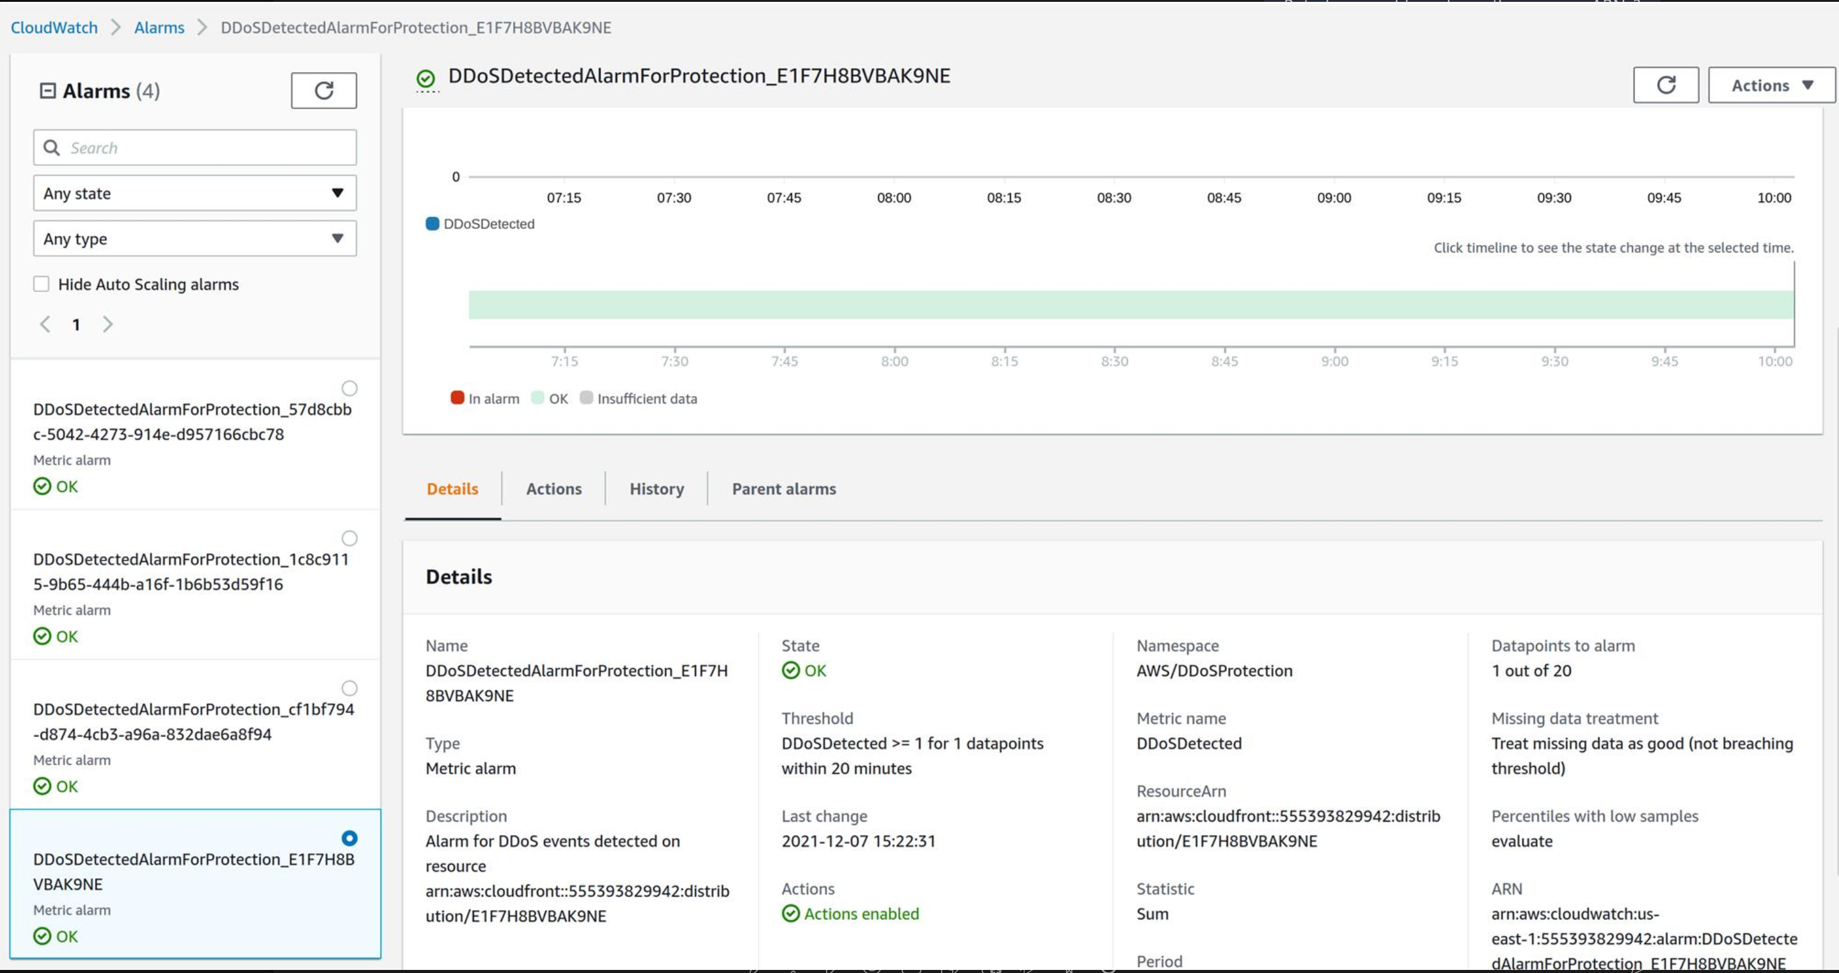
Integration with Cyber Security
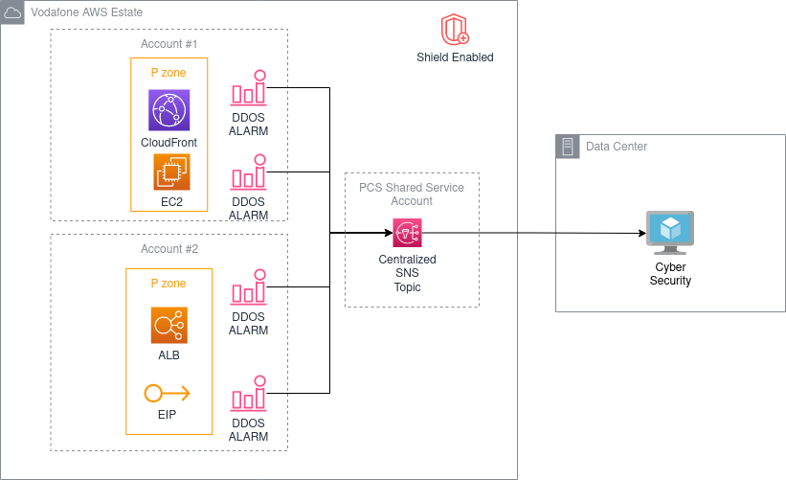

(OPTIONAL) Health-Based Detection
The accuracy of AWS Shield increases when Route53 health checks are associated with AWS Shield protections. This is optional but recommended.

DEVELOPMENT TEAM's RESPONSIBILITY
This is not something PCS are able to do because we do not know the application URL, the response (basically we do not have the understanding of an application to know what it means for it to be "healthy").
Therefore, it is the responsibility of a tenant to configure it.

CLOUD FRONT
resource "aws_route53_health_check" "health_check_cloud_front" {
fqdn = aws_cloudfront_distribution.cloud_front.domain_name
port = 443
type = "HTTPS"
resource_path = "/index.html"
failure_threshold = "5"
request_interval = "30"
tags = var.tags
}
Reference https://registry.terraform.io/providers/hashicorp/aws/latest/docs/resources/route53_health_check
The result should be something like:
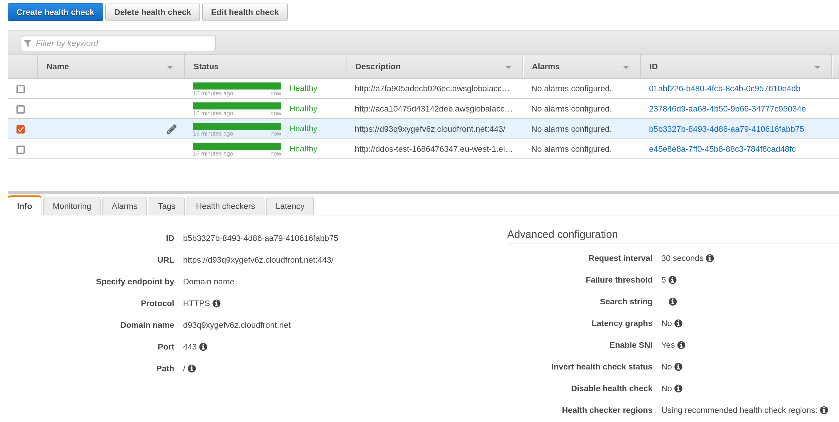
NOTE there does not exist a terraform resource to associate a health check with a Shield protected resources. You will have to do it in the console or via the CLI:
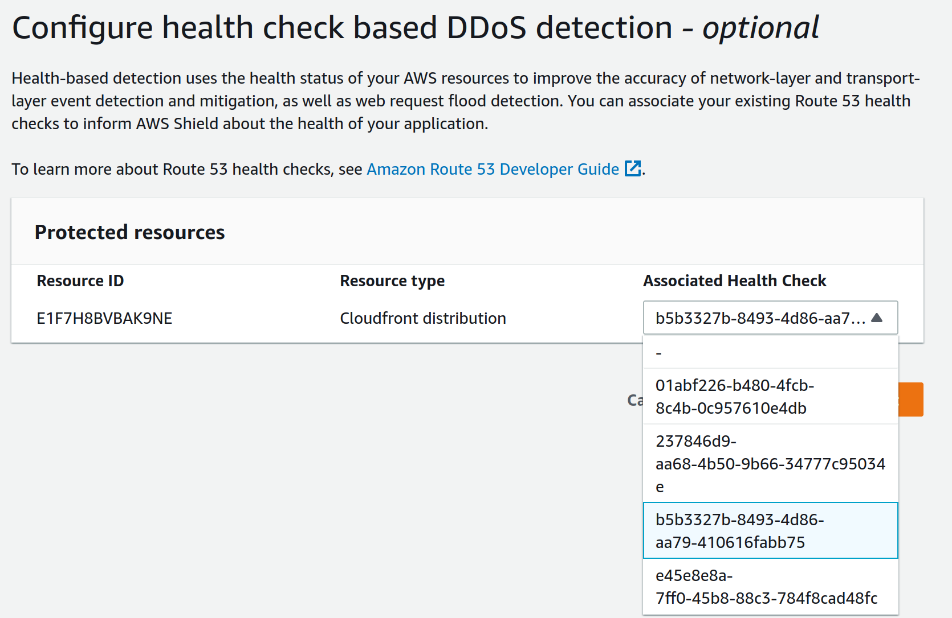

AWS Shield Advanced | 3. IAM
IAM
Developer N/A
There seems to be only 2 policies for the Shield service and neither seems suitable to be used by developers in tenant accounts. The AWSShieldDRTAccessPolicy managed policy is over-priviledged and it is not suitable to grant it to developers. In particular, one of the statements lists all API actions in the WAF and Shield APIs. There is a risk that someone with the policy could disable shield subscription in the account, disable WAF rules, un-protect resources etc. The description does not suggest that it should be used by tenants.

To enable developers to use shield in non-PROD environments, tenant accounts are advised to create a less privileged customer managed IAM policy that allows to:

enable protections for support resources
view AWS Shield resources
In PROD these actions would be done via a pipeline with admin access so a custom policy for users is not needed.

resource "aws_iam_policy" "shield_devs" {
name = "CustomShieldAccessPolicy"
path = "/"
description = "Custom AWS Shield policy for developers"
policy = jsonencode({
Version = "2012-10-17"
Statement = [
{
Action = [
"shield:Associate*",
"shield:Create*",
"shield:Describe*",
"shield:Get*",
"shield:List*",
"shield:TagResource",
"shield:UntagResource",
"shield:UpdateProtectionGroup",
]
Effect = "Allow"
Resource = "*"
},
]
})
}

See https://docs.aws.amazon.com/service-authorization/latest/reference/list_awsshield.html#awsshield-actions-as-permissions

Product Owner
arn:aws:iam::aws:policy/ReadOnlyAccess
Please bear in in mind the ReadOnlyAccess policy grants read only access to most resources. If you want to be more granular you might wish to create a managed policy:

resource "aws_iam_policy" "shield_read_only" {
name = "CustomReadOnlyShieldAccessPolicy"
path = "/"
description = "Custom read-only AWS Shield policy"
policy = jsonencode({
Version = "2012-10-17"
Statement = [
{
Action = [
"shield:Describe*",
"shield:Get*",
"shield:List*",
]
Effect = "Allow"
Resource = "*"
},
]
})
}

Security
arn:aws:iam::aws:policy/SecurityAudit

Enabling CloudFormation Termination Protection

You can prevent a stack from being accidentally deleted by enabling termination protection on the stack. If a user attempts to delete a stack with termination protection enabled, the deletion fails and the stack, including its status, remains unchanged. You can enable termination protection on a stack when you create it. Termination protection on stacks is disabled by default. You can set termination protection on a stack with any status except DELETE_IN_PROGRESS or DELETE_COMPLETE.
Enabling or disabling termination protection on a stack sets it for any nested stacks belonging to that stack as well. You can't enable or disable termination protection directly on a nested stack. If a user attempts to directly delete a nested stack belonging with a stack that has termination protection enabled, the operation fails and the nested stack remains unchanged.
However, if a user performs a stack update that would delete the nested stack, AWS CloudFormation deletes the nested stack accordingly.
Termination protection is different than disabling rollback. Termination protection applies only to attempts to delete stacks, while disabling rollback applies to auto rollback when stack creation fails.
To enable termination protection when creating a stack
On the Specify stack options page of the Create stack wizard, under Advanced options, expand the Termination Protection section and select Enable. For more information, see Setting AWS CloudFormation stack options in Creating a stack on the AWS CloudFormation console.
To enable or disable termination protection on an existing stack.
1.Sign into the AWS Management Console and open the CloudFormation console at https://console.aws.amazon.com/cloudformation/.
2.Select the stack that you want.
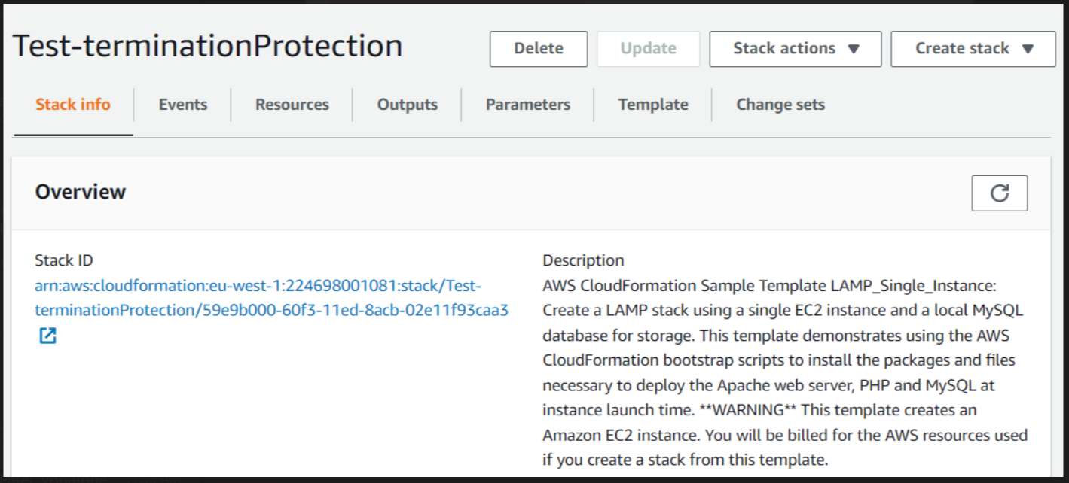
Note : If NESTED is displayed next to the stack name, the stack is a nested stack. You can only change termination protection on the root stack to which the nested stack belongs
3.In the stack details pane, select Stack actions and then Edit termination protection. CloudFormation displays the Edit termination protection dialog box.

4.Choose Enable or Disable, and then select Save.

To enable or disable termination protection on a nested stack.
If NESTED is displayed next to the stack name, the stack is a nested stack. You can only change termination protection on the root stack to which the nested stack belongs. To change termination protection on the root stack:
1.Sign into the AWS Management Console and open the CloudFormation console at https://console.aws.amazon.com/cloudformation/.
2.Select the nested stack that you want.
3.In the Stack info pane, in the Overview section, select the stack name listed as Root stack. CloudFormation displays the stack details for the root stack.
4.Choose Stack actions and then choose Edit Termination Protection. CloudFormation displays the Edit termination protection dialog box.
5.Choose Enable or Disable, and then select Save.

Controlling who can change termination protection on stacks.
To enable or disable termination protection on stacks, a user requires permission to the cloudformation:UpdateTerminationProtection action. For example, the policy below allows users to enable or disable termination protection on stacks.
For more information on specifying permissions in AWS CloudFormation, see Controlling access with AWS Identity and Access Management.
Example A sample policy that grants permissions to change stack termination protection.
{
"Version":"2012-10-17",
"Statement":[{
"Effect":"Allow",
"Action":[
"cloudformation:UpdateTerminationProtection"
],
"Resource":"*"
}]
}

